The Development of Human Personality: Nature Vs. Nurture
Student’s Name
Instructor’s Name
Date

The Development of Human Personality: Nature Vs. Nurture
Personality is a very crucial part for every person around the world because it can determine how people can interact with other individuals, their moods, behaviors, and the decisions they make. Personality makes people be who they are, and that's why it is regarded as a significant area of study in psychology. Psychologists have always been researching the factors that lead to a particular personality and influence. Therefore, they have performed extensive researches to identify if either nature influences the personality of individuals, such as inherited genes from their parents or nurture such as religion, environment, childhood interactions, or culture. This paper will research nature and nurture as a factor and how the factors influence personality of an individual as well as their share to the development of personality characteristics of individuals.

Nature
Kandler et al. (2016) argue that for a very long time, physical characteristics such as skin pigment, the color of eyes, and the particular diseases are determined by genetic inheritance from parents. However, the reason that individuals can inherit specific physical characteristics resulted in the research of if a person inherits certain personality traits, behavior propensities, and mental capabilities through genes. Consequently, nativists are individuals who assume exciting genetic positions. Therefore, the elementary expectations are the human traits results from the evolution, and thus people variations are brought by their exceptional genetic code. Moreover, 50% of a person’s genetic makeup comes from their parents; that is why it is easy to hear one says that "like father like son" or “she is absolutely like her mother."

Similarly, based on biological theories of personality, it undertakes that the variation in personality is comparatively founded in systems and structures in the central nervous systems, for instance, the neurotransmitters and genetics (Corr & Wright, 2015). They are leading to a conclusion that people's personality varies based on the genes which people develop as well as how the bodies control the genes. Additionally, according to Velázquez et al. (2015), performed research on adoptive children and twins and found out that genetic makeup has a significant effect on the personality of child-rearing. Consequently, nature brings about the character of a person taking care of kids and ensuring equity to all kids hence providing support to the kids. There are several examples stated to prove that personality traits are influenced by nature; for instance, Bernstein (2018) anticipated that language is attained by the use of native language gaining expedient; also, Fraud's theory of aggression is another innate drive.

Nurture
The theory argues that when children are born, their mind is always at a blank state which develops progressively due to experiences gained. Hence, the characteristics and behavioral alterations that occur during childhood are the outcomes of learning. Moreover, how a child is nurtured is what controls the important features of child growth. Several people have argued about how behavior personality is attained through nature, for example, according to Lansford (2016), argued using the bobo doll experiment that aggression is cultured from the environment where a person has to observe to be able to learn. Also, language is erudite through behavior influencing practices.

The environment in which people live has a significant influence on the personality trait of a person. The activities that were available during childhood life played a vital role in adult life by developing the personality. Much of the personality available to individuals is created on social interest and cognitive capabilities as well as variation of the individual’s capacities, and all the capabilities are developed when people interact with the environment. Furthermore, the personality of an individual is determined by the culture available in the society the person is raised in, as well as how the person interacts with other individuals in the environment. For instance, children who are raised and undergoing through bullying, they tend to be introverts in their adult life because of the experiences they encountered in their early life.
Nature and Nurture
There exist many facts which indicate that both nature and nurture influence the personality characteristics of individuals. Hence making it hard for people to decide which of the two influences personality, nonetheless, the question to be asked is how much the factors influence personality because both nature and nurture influence how an individual becomes (Soto et al., 2015). Personality trait of a person is also determined by the individual choices, thus presenting a share of all factors contributing to personality characteristic of a person that is genes, environment and individual choices will be as follows.

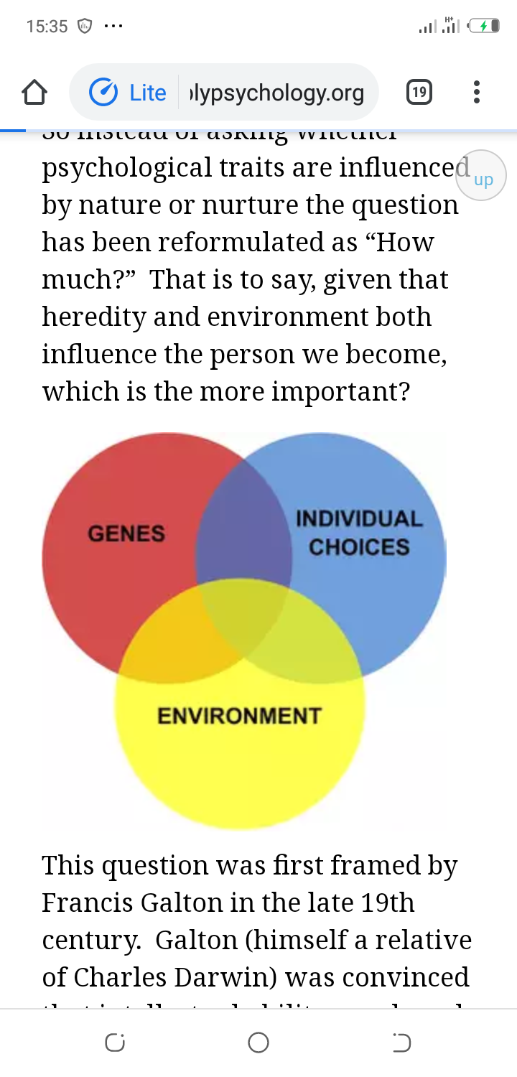

In summation, the argument between the natural vs. nurture in personality influence is much bigger; for instance, nature supporters argued that intelligence is determined by the previous generation genes hence is inherited. However, the situation can be improved through better breeding of human beings, by spreading the genes to other people who have lower IQ. On the other hand, the environmentalist argues by supporting their claims that the difference in intelligence is due to social inequalities in availability of both opportunities and resources. Consequently, people who are raised in slums will have a lower test of intelligence because they are denied an equal chance with other privileged individuals in society.

References
Bernstein, W. M. (2018). A basic theory of neuropsychoanalysis. Routledge.
Corr, P. J., & Wright, J. D. (2015). Personality, Biological Models of. International Encyclopedia of the Social & Behavioral Sciences. 2nd ed. Oxford: Elsevier, 857-62.
Kandler, C., Riemann, R., Angleitner, A., Spinath, F. M., Borkenau, P., & Penke, L. (2016). The nature of creativity: The roles of genetic factors, personality traits, cognitive abilities, and environmental sources. Journal of Personality and Social Psychology, 111(2), 230.
Lansford, J. E. (2016). Bobo doll experiment. Encyclopedia of Personality and Individual Differences, 1-3.
Soto, C. J., Kronauer, A., & Liang, J. K. (2015). Five‐Factor Model of Personality. The Encyclopedia of Adulthood and Aging, 1-5.
Velázquez, J. A., Segal, N. L., & Horwitz, B. N. (2015). Genetic and environmental influences on applied creativity: A reared-apart twin study. Personality and individual differences, 75, 141-146.

